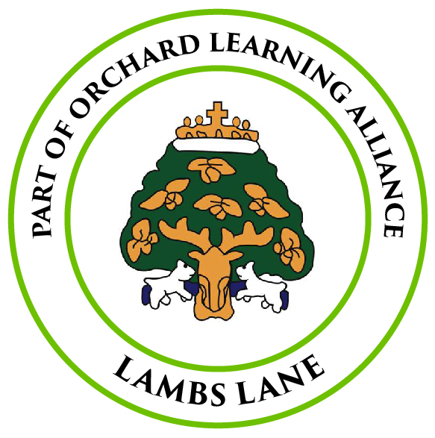
LAMBS LANE PRIMARY SCHOOL
APPLICATION FOR IN-YEAR ADMISSION

Please ensure that all questions are answered, where applicable; incomplete forms may result in a delay in the admissions process.

Applications can take up to 15 school days to be processed. All applications will be considered by a member of the Lambs Lane Senior Leadership Team. Once a decision has been reached, you will be informed of the outcome by the Admissions Administrator.

SECTION 1: APPLICATION INFORMATION
Date for admission.  Enter today’s date to indicate you want a place as soon as possible. | Day: Month: Year:
Reason for your application.  Please provide a copy of your child’s passport or birth certificate.  If moving from abroad, we will also need to see your passport and any necessary visa(s). | ○ Moving to the area from within the UK  ○ Moving to the area due to a posting (crown servants/service personnel)  ○ Moving to the area from abroad  ○ Moving within the local area  ○ Wanting to transfer school but not moving  ○ Other (please specify):

SECTION 2: STUDENT’S DETAILS
Legal First Name |  |  | Preferred First Name
Legal Surname |  |  | Preferred Surname
Middle Name(s) |  |  | Year Group
Date of Birth |  | Gender at birth |  | Preferred Pronouns |  | He/His She/Her They/Their
Current Address

SECTION 3: YOUR DETAILS
If you are caring for someone else’s child for more than 28 days and you are not an immediate relative, it is a legal responsibility to contact the local authority: www.wokingham.gov.uk

 | Parent 1 | Parent 2
Name and Title
Address (if different from the student)

Relationship to Student
E-Mail
Telephone Number(s)

Parent Responsibility | YES / NO | YES / NO
Additional Report*

*The Law states that parental responsibility is held by each parent even if they are separated or divorced and, in such cases, each parent can receive a copy of their child’s annual academic report. If more than one report is required, please indicate below.

If you are moving house, you will need to provide evidence of the new address (including disposal of your previous home for local moves) before it can be used for the application. Please advise if there are any changes to these plans as this may affect the allocation of a school place. This evidence needs to be submitted with your application.

New address
Date of Move
Evidence | ○ Solicitor’s letter confirming exchange of contracts  ○ End of Tenancy Agreement for previous address  ○ Tenancy Agreement for new address  ○ Moving to the area from within the UK

If you are not moving house, please provide two current documents with your application as proof of address.
○ Council Tax statement
○ Utility bill
○ Benefits statement
○ Bank statement
○ Prescription form
○ Other (please specify)

SECTION 4: CURRENT OR LAST SCHOOL
Please note that Lambs Lane may seek further information from your child’s current school and/or Wokingham Borough Council to verify information provided on this form, or to determine whether the Fair Access Protocol should be considered for this application.

Name of school
Address
Telephone Number
Date your child started at this school
Date of last attendance, if not currently attending
Name of school previously attended before current school
Has your child had any fixed or permanent exclusions? If yes, please give details
Has your child been offered or accepted a Managed Move? If yes, please give details
Reason for leaving or request to change schools
Have you discussed the proposed change of school with your child’s current school?
Any additional information which you consider is relevant to this application?
Do you consider the application should receive consideration for Fair Access Protocol? (www.wokingham.gov.uk)

Have you also made application to any other schools in the area? If yes, please name the school(s) in order of preference. | 1.  2.  3.  4.

SECTION 5: ADDITIONAL INFORMATION
In order to establish the most appropriate placement for each student, we need to ask additional questions of all applicants.

Does the student have an Education, Health & Care Plan (EHCP)? | If Yes, you should not complete this form. Please contact the Special Educational Needs team for the Local Education Authority in which they live
Does the student have any special educational needs (but no EHCP)? If yes, please provide details.
Does the student have a disability or medical condition that has impacted their attendance or participation at school? If yes, please provide details.
If your child (or family) have either currently or recently been involved with a TAF (Team Around the Family), or a CIN (Child in Need) or Social Worker please give details.
Is the student working with or being supported by other individuals or groups, such as Education Welfare Officer, Educational Psychologist, CAMHS etc. If yes, please give names and contact details.
Is the student considered to be a carer? If yes, please provide details.
Is the student a refugee or asylum seeker?
Is this student looked after or previously looked after by a local authority? If yes, please state the name of the LEA
Is the student adopted or under a special guardianship order? If yes, please provide details.
Have there been any safeguarding concerns regarding your child?
If you are applying for exceptional medical or social reasons, please give details and confirm that you have included the appropriate professional evidence to support your case.
Are you also making an application at this time for any other children who are part of the same family? Please give details so that their applications may be considered together.
Does your child already have a sibling(s) living at the same address already attending Lambs Lane? If yes, please give their names.

I enclose/attach supporting information/evidence relating to:
○ Section 1
○ Section 2
○ Section 3
○ Section 4
○ Section 5

Please note that the 15 day application process will commence once all information/evidence is received.

SECTION 6: DECLARATION
Personal information contained in this form is subject to (EU) General Data Protection Regulations (GDPR). South Lake is registered under the Data Protection Act for holding personal data as detailed in our privacy notice on our website: www.southlakeprimary.co.uk

The local authority and South Lake reserve the right to carry out further investigations and require additional evidence to verify information contained in this form, including contacting the child’s previous school.

Parent Declaration:

I declare that the information I have given on this form is correct and that I am the person with parental responsibility for the child named above.

I understand that this information will be stored securely and may be shared with appropriate agencies.

I have read and understood the school’s privacy policy.

I confirm that, to the best of my knowledge, the declared address will continue to be the child’s residence beyond the start of school and will inform Lambs Lane of any changes.
I have read and understood the admission arrangements and criteria and have completed and submitted any additional or supplementary information forms which may be required.

I understand that applications can take 15 school days to process once all supporting evidence has been submitted.

I understand that any place offered may be withdrawn if I give false or misleading information.

I give permission for my child’s previous school(s) to be contacted and information regarding this application to be obtained.

Signature of parent/carer ………………………………………………………………………

Print Name ………………………………………………………………………

Date ………………………………………………………………………

Please return the completed application form and supporting evidence documents to:
The Admissions Administrator
Lambs Lane Primary School
Back Lane
Spencers Wood
Reading
RG7 1YG

Or e-mail: admissions@lambslane.wokingham.sch.uk

