Copy | Content
It’s tough watching your child struggle. Whether it’s settling back into school, health worries, or simply dark days making everything harder - help is here!  💬 Text our health professionals for confidential advice to support your child.  Text us at 07312 263194  Find help near you  ➡️ chathealth.nhs.uk/start-a-chat | 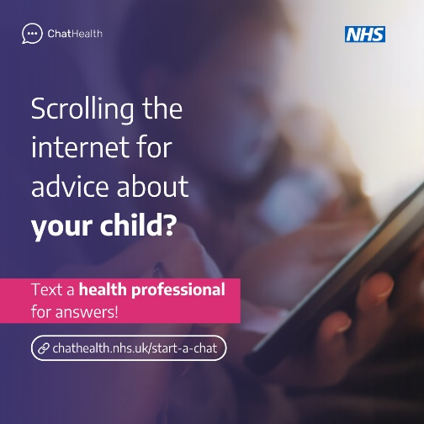

Have questions about your child’s health? Wondering why they’re finding it hard to settle back into school?  💬 Our school nursing teams are here to offer friendly, anonymous support and advice you can trust.  Text us at 07312 263194  Find help near you  ➡️ chathealth.nhs.uk/start-a-chat | 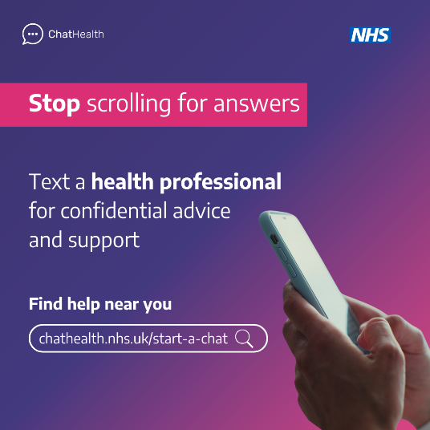

Back-to-school blues? If your child is having trouble adjusting, don’t face it alone.  💬 Reach out to a health professional who understands what you’re going through. We’re just a text away.  Text us at 07312 263194  Find help near you  ➡️ chathealth.nhs.uk/start-a-chat | 